May 2022 Annual Town Meeting

Article 21: Appropriate for Emery Grover Construction Design

- What does this article accomplish?

Article 21 requests $19,400,000 for construction of a project to fully renovate the Emery Grover (EG) School Administration and Operations Building at its present location on Highland Avenue. The project also includes limited and essential upgrades at the Hillside Elementary School which will be used as swing space for school administration and operations personnel during construction.

- What is the design scope of the overall project?

The original June 2020 design for the Emery Grover project was an existing building renovation and addition with a total of of 34,717 gross square feet that included the following components: historic renovation of the EG exterior (façade); renovation and modernization of the interior spaces; and the construction of a three-story addition in the rear of the building. This renovated building proposal with a basement included 22,965 SF of program space on four floors.

Since that time the building scope has been reduced by approximately one third to a total of 21,750 Gross Square Feet (GSF), fitting within the existing EG footprint while still meeting program needs. The “value engineering” (VE) included in the updated design eliminates the need for the three story addition, reduces the net program of spaces to 14,404 net square feet, located on four floors of the existing building structure. These reductions reflect a more efficient use of shared spaces, the construction of common work areas, and keeping instructional & information technology/head end room functions in existing spaces within the school buildings.

Interior spaces will be organized in a way that aligns departments to enable appropriate and flexible workspace and workflow. For example, the Student Support Services and Student Learning departments will be located together in the lower level of the building which will enable these departments to collaborate and team more effectively. The entry level of the building will consolidate key functions that meet the needs of families, including registration, transportation, and nutrition. Shared office spaces and conference rooms are also provided as well as ample space for community meetings.

A new ramp from the parking lot and an elevator provides handicapped access to all levels. A small service entry addition provides access for deliveries and the district’s Production Room.

Emery Grover Site Plan

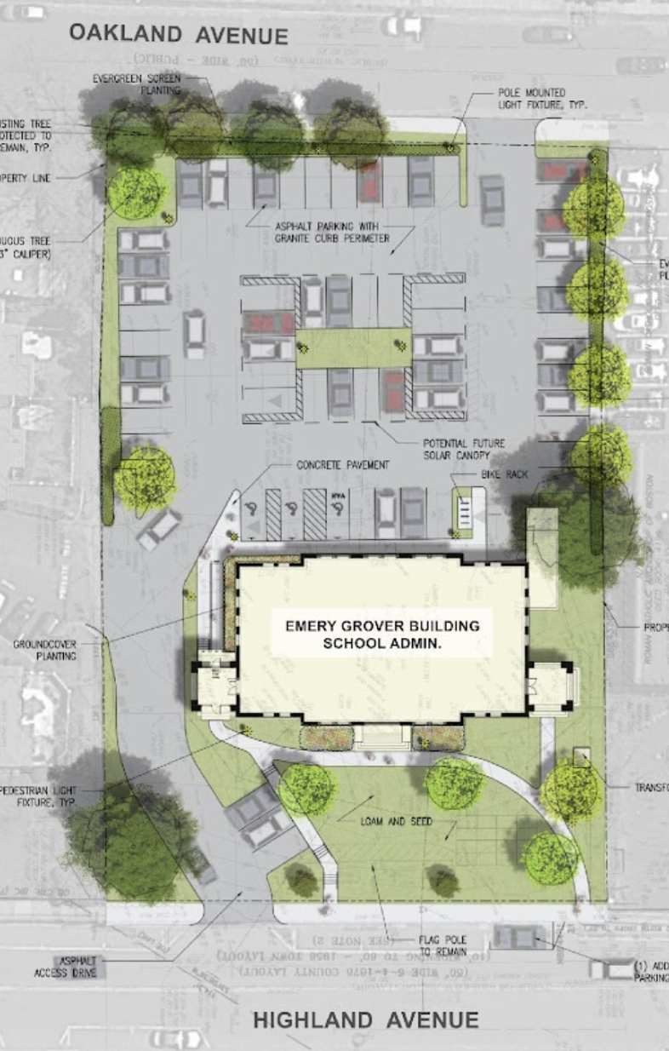

Proposed Site Plan and Scope
21,108 Gross Square Feet
14,404 Net Square Feet

Detailed information about the original project scope is presented in the feasibility study completed by Bargmann Hendrie + Archetype, Inc. (BH+A) in June 2020. The report is available online at www.needham.k12.ma.us.

- Are there exterior and interior design plans available to view?

Preliminary information about the EG design is available here: EG Design. Preliminary design and scope work has been submitted to various Town boards for discussion and approval. You may view this information here: Preliminary EG Design work and also here: EG Site and Building Design work.

- What is the anticipated cost of the project and how would it be funded?

The 2021 updated project cost was estimated at $20.875 million, which included funds to make the Hillside school ready for temporary occupancy by school administration staff while the EG is under construction. Although the Architect, Bargmann Hendrie & Architype (BH+A), estimated that approximately 85% of the project could be eligible for Community Preservation Act (CPA) funding, the anticipated contribution from CPA funded cash and debt based upon guidance from the Community Preservation Committee will be $6.0 million. If approved by Town Meeting, the remainder of the project cost is anticipated to come from free cash and debt repaid by the General Fund within the levy limit (no debt exclusion override required).

The most recent Design Development (DD) cost estimates projected a $2 million cost increase to $22.875 million. This DD estimate has a 20% contingency approved by the Permanent Public Building Committee (PPBC) that includes Bidding (3%), Construction (7%) and Owners (10%) contingency. The projected cost escalation is due to current construction market volatility, supply chain issues, escalating fuel prices, and labor shortages. Depending on how the General Contractor bids come in later in the fall, an additional $2 million funding could be requested at the fall Special Town Meeting (STM – Oct. 2022).

- What is the planned timeline?

A preliminary project timeline appears below. The anticipated Town Meeting funding schedule is: a May 2022 Annual Town Meeting request for construction and construction administration funds, followed by an October 2022 Annual Town Meeting request for additional contingency, based upon construction bids. The construction budget includes funds for both the Hillside improvements and the Emery Grover renovation. The Hillside updates are expected to take 6 months and the Emery Grover construction is anticipated to take 16 months:

Design Funding previously received: Oct '21 STM,
Detailed Design Hillside: Nov’21 – Mar’22
Bidding (Hillside): Mar ’22 to Apr’22
Construction Funding (Hillside Swing Space and Emery Grover Renovation): May ’22 ATM
Construction of Hillside as Swing Space: June ’22 – Nov ’22, 6 Months
Detailed Design Emery Grover: Nov’21 -Aug’22
Bidding (Emery Grover): Sept’22-Oct’22
Construction Contingency Funding (based on bids): Oct’22 STM
Award of Construction Contract & submittals: Nov’22-Dec’22
School Admin move to Temporary office at Hillside: Dec’22
Emery Grover Construction: Jan ’23 – May ’24, 16 months
New Building Opens: June’24
School Admin moves back to EG: Summer ‘24

If the project is further delayed, the project cost could increase to reflect construction price escalation.

- How does this project fit within the School Department’s plan for addressing school facility needs, including renovating Mitchell and Pollard?

The School Committee has a two-pronged plan for addressing its facility needs, starting with its plan to address the immediate and overwhelming deficiencies at the Emery Grover School Administration and Operations Building. The second prong of the plan tackles the pressing needs of school buildings, including: Providing capacity at the elementary schools for enrollment growth, addressing overcrowding at the High Rock School and modernizing the Mitchell Elementary and Pollard Middle Schools.

In 2020 the School Department completed a School Master Plan study to investigate options for its school buildings. Several scenarios were studied, including a ‘preferred plan’ to a) position Grades 6-8 under one roof at the Pollard School, b) repurpose High Rock as a sixth elementary school and c) renovate the aging Mitchell School as a three-section elementary school. The School Department currently is engaged with the Select Board, Town Manager, PPBC and Finance Committee to develop a financing plan for these and other major Town projects (such as the DPW project) over the next 5-15 years. The Boards hope to complete their work by the end of this fiscal year.

The two-pronged plans to address Emery Grover deficiencies and to renovate the Mitchell, Pollard and High Rock schools are proceeding along separate, parallel tracks that are not in conflict with one another. These projects involve different funding sources, approvals and processes. The Emery Grover renovation is proposed to be funded from debt repaid by the General Fund within the levy limit (no debt exclusion override). The Master Plan projects to renovate Mitchell and Pollard schools could involve Massachusetts School Building Authority (MSBA) participation on a timetable that MSBA sets and will be funded by a debt exclusion override.

- Given the School Department’s other, major facility needs, does it make sense to defer Emery Grover to a later date?

No, the Emery Grover Building has immediate needs, which cannot be deferred any longer.

The building has pressing infrastructure, accessibility, and health & safety needs, due to decades of deferred maintenance. It lacks basic life safety systems, including fire sprinklers, fireproof stairwells and a second means of egress from the third floor. It is not ADA accessible and lacks internal ventilation (interior offices have no access to fresh or circulated air.) It is energy inefficient, and upgrades are needed to windows, the roof, and wall insulation. The antiquated mechanical/electrical/plumbing system requires total replacement. Finally, the building does not comply with modern building codes.

The deficiencies of the Emery Grover building have been studied and documented for over thirty years by four Town Master Plans, including: 1990 Anthony Tappe and Associates, Inc.; 1999 Kaestle Boos Associates, Inc.; 2006 DiNisco Design Partnership, Limited; and 2014 HKT Architects. Despite Emery Grover’s deficiencies, other Town projects have been prioritized for funding including: Eliot Elementary School, Broadmeadow Elementary School, Needham High School (and the High School Expansion), the High Rock 6th Grade Center, Newman Elementary Repair, Sunita Williams Elementary School, PSAB, Town Hall, the Senior Center/ CATH, the DPW Salt Storage Building, the DPW Storage Building & Fuel Station, Rosemary Recreation Center, and the Memorial Park Field House. Meanwhile, the key code compliance issues at Emery Grover were deferred until an unspecified future ‘major renovation’ project could be completed. As a result, the condition of the Emery Grover building deteriorated over time and the documented needs have remained unaddressed. In addition, minor repairs have not kept up with the ‘deferred maintenance’ required to keep the Town’s oldest public building (constructed in 1897) operational.

- Will the educational program for children be compromised if Emery Grover is prioritized over Mitchell or Pollard?

No, children will not be adversely affected. The Town will continue to maintain its eight school buildings, as it does now, by making significant investment in ongoing repair and maintenance.

As noted above, the plan to renovate Mitchell and Pollard and to address overcrowding at the High Rock School is proceeding along a separate, but parallel track to Emery Grover. These school building projects require different funding sources, approvals and design processes. School construction projects frequently benefit from MSBA funding and require a town-wide override, as occurred with the recently constructed Sunita Williams Elementary School. The MSBA sets the schedule and timetable for the projects it is involved with. Emery Grover will be funded within the tax levy and with help from Community Preservation Act funding, like the Town Hall project. The School Committee is committed to addressing the needs of both Mitchell and Pollard and is moving forward with those projects as quickly as possible.

- What other options to historic renovation on Highland Avenue were considered?

Several alternative options to address the space needs of school operations were considered, but all were rejected.

  - Relocating School Administration to other Town-owned sites

BH+A studied several options that relocated school administration to other Town-owned properties. The PPBC rejected all of the other sites for the following reasons:
- 0 Greendale – lacked frontage (purchase and demolition of an adjacent property might be required to meet 150-foot frontage requirement), and proximity to Route 128
- 0 Harris Avenue – proximity to wetlands, inappropriate fit with the existing neighborhood, and the potential need for underground parking.
- Dwight Road – need for significant site work, steep access drive and significant grade change, and need for terraced parking above and below the building.
- Stephen Palmer/ Greene’s Field – the existing building is under lease agreement through at least 2027, Green field in active use.
- Hillside School – Although the site offered ample room for parking and future expansion, the remoteness from Town Center, existing environmental issues and the cost of code compliance was of concern. Both demolition and new construction and comprehensive renovation were evaluated.
- Other School Buildings – there is insufficient space in existing Needham school buildings to house the administrative offices.

  - Selling Emery Grover for the value of its land and redevelopment potential

The 2021 assessed value of the property is $3,152,800.
There have been two studies conducted to determine the potential value of the site for a development: In 2020 BH+A conducted a property best use study, to determine the potential value of the land and building to a developer. In September 2021 the superintendent of schools asked two local developers, Petrini Corporation and J. Derenzo Properties, to review the 2020 results and provide additional information.
- BH+ A 2020 Study: The 2020 study results are summarized on next page:

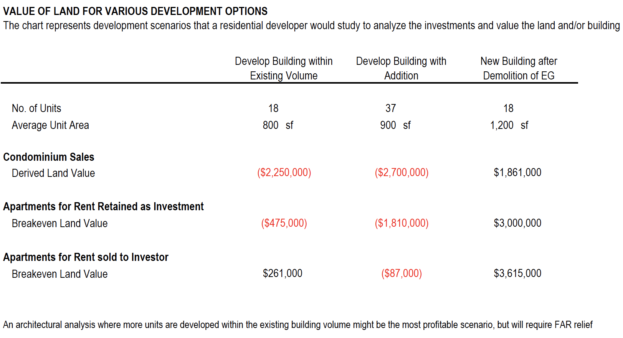

The study concluded that neither historic redevelopment of the existing structure, nor construction of a new building after demolition, would be particularly profitable to a developer. As such, the potential resale value of the Highland Avenue parcel would likely be relatively low.

The development strategies that involved renovation of the existing structure (either by redeveloping the existing building within its current volume or redeveloping the building with a substantial addition) were determined to have little or no positive land value. This was because it would be cost prohibitive to redevelop the historic structure as condominiums for sale or apartments to rent, given the high cost of construction and inefficient building layout that would result in substantially lower salable or rentable area. In addition, the study concluded that market values in Needham do not support the higher construction costs associated with historic redevelopment.

Although the study determined that cleared land (following demolition of the existing building) would have positive land value, the zoning restrictions on the site would limit the fair market value of the land to between $1,800,000 (in the case of a townhouse condominium project with average sales of $550 per square foot) and $3,000,000 (in the case of rental apartments.) The zoning restrictions include limitations on the maximum building height, floor area ratio, and number of dwelling units per acre.

• September 2121 Study: Needham-based Petrini Corp. and J. Derenzo Properties reviewed the original BH+A analysis and provided an updated perspective about the value of the parcel for a residential and/or commercial development project.

Petrini Corp. suggested the parcel would be worth $2.1 million for a residential project, and J. Derenzo Properties indicated that the value for a residential and/or commercial project would be no more than $2.0 million. These values are at the lower end of the original BH+A study estimates.

  - Leasing office space for school administration

Both BH+A and the PPBC have analyzed the use of leased space for school administration, as an alternative to construction/ renovation.

These studies concluded that it would be difficult to find contiguous space of the size required (approximately 20,000 square feet) locally in Needham. Recently the School Department issued a Request for Information (RFI) to Needham’s broker community, for the purpose of identifying potential available spaces within Needham. Unfortunately, the RFI received no responses.

Additionally, the studies concluded that leasing would only make financial sense in the 3-5 year short term, such as swing space use during construction, but not in the longer term. On a long-term basis, the cost of renting would be roughly equivalent to the cost of construction after twenty years, without the benefit of a permanent solution to administration space needs. Additionally, renting space on either a short or long-term basis would involve some ‘fit out’ modification to adapt the space to School Department use. The estimated cost of improving leased space could range between $1.6 million – $2.6 million.

  - Occupying other school buildings

There is no room in any of the other active school buildings for school administrative staff. As an example, the Sunita Williams Elementary School, which opened in 2019, is already over its design capacity of 430 students. While class sizes at Sunita L. Williams are within acceptable School Committee guidelines, the school’s total current enrollment of 506 means that specialized classrooms (e.g., technology and Spanish) have been repurposed for general classroom use leaving no extra spaces at that school. All other school buildings need space for classrooms, school programs, student services, and meetings.

Although there is sufficient room for administration at the old Hillside School, the 1959 building would require major structural, accessibility, HVAC and fire and life safety modifications to extend its useful life. In addition, significant code upgrades would be required. The Hillside Elementary use was changed from Educational to Business (a less restrictive use in the building code) for Needham Police and Fire temporary use. Changing the use back to an educational use designation would require the facility to fully comply with the current building codes for a new school building. The preliminary estimated cost of a new or renovated building at the Hillside School site would be in the $22.6 – $27.5 million range. The total cost of these projects includes removal of the contaminated soil and construction of a new containment slab underneath the building.

  - Occupying other Town office buildings

Although Needham does have other municipal buildings, it does not have the excess space that would be necessary to absorb the school administrative functions either altogether or in separate locations.

- How does the cost of historic renovation compare to new construction, or the cost of constructing administrative space at the Hillside School site?
Although the cost of historic renovation is typically higher than the cost of new construction on a per square foot basis, the total cost of renovating the Emery Grover building is the least costly alternative of all the project options that were considered, including new construction on the Emery Grover site. In addition, historic renovation at the Emery Grover site is also less costly than either renovating Hillside school for school administration use or constructing a new building at the Hillside School site.
  - Is historic renovation more costly than building new office space?
No, the cost of renovating Emery Grover is approximately equal to the cost of new construction on the same site.

Although the cost of historic renovation is typically higher than the cost of new construction on a per square foot basis, the $20.875 million estimated total project cost of renovating Emery Grover is approximately equal to the estimated total project cost of constructing a new building on the same site ($21.829 million.) This is because the cost of renovation would be reduced by the adaptive reuse of the existing building envelope, building foundation and some interior structures in the renovation project. Although architectural fees would be lower for a new building, due to the removal of various uncertainties when constructing a new building, a new construction project would include the additional, offsetting cost of demolishing the existing building. The cost of demolition would be at a premium for this project, given the mandatory, six-month, Town of Needham demolition delay that would result from the historic nature of the existing building. In addition, it is likely that a new building would have an ‘aspirational’ design that adds to the overall project cost, given the building’s prominent location on Highland Avenue and proximity to the downtown area.

On a net cost basis, however, the cost of historic renovation has advantages over new construction since Community Preservation Act (CPA) funding could offset a portion of the renovation cost. BH+A estimates that approximately 85% of the total project cost could be eligible for CPA funding, although the actual CPA funding amount will be determined by the Community Preservation Committee. The CPC voted to support $6-million for the Historical renovation.

  - How does the cost of historic renovation compare to the cost of leased office space?
Historic renovation is also a less expensive option than leasing office space for school administration. Based on commercial rental rates of approximately $40/s.f. - $45/s.f., a 21,000 s.f. lease would cost between $23M - $26M over twenty years, after which time the Town would still be confronted with the problem of where to house school administration. This compares to an historic renovation expense of $21-$23M, the gross cost of which would be reduced by net available Community Preservation Act funding.

  - Would building at the old Hillside School site make more sense than historic renovation?
Historic renovation at the Emery Grover site is also less costly than either new construction or renovation at the Hillside School site. The estimated cost of building a new 18,000 GSF building at the Hillside School site is $22.6 million (or $26.9 million if the design included an additional 5,000 GSF for administrative technology.) This compares to the cost of partially renovating Hillside School for school administration use at $27.5 million. The renovation project would demolish the 1997 modular classrooms and the 1968 addition, retaining approximately 19,000 square feet of space on the upper level and 12,000 square feet on the lower level for reuse by school administration. In the renovation option, school administrative technology could be housed in the renovated space.

Although the Hillside options would eliminate the need for swing space during construction, these options are both more costly than construction on the Emery Grover site due to the need to remove the contaminated soil from that site, and to construct a ventilated plenum below (or at) the first level of the building to enable any off gassing from the soil that may pass through the containment slab to be ventilated outside of the building. The cost of both Hillside options also includes hazardous materials abatement. The Hillside options also require occupancy of EG for another 3-4 years. The low floor to ceiling heights within the existing building complicate the installation of contemporary and code compliant MEP systems.

- How well suited to school administration activities is the Highland Avenue site?

In addition to being available and a cost-effective space, the Highland Avenue site is extremely well suited to school administration and operation activities, given its central location in Town.

This central location, served by both buses and trains, provides equitable access to our families, although the current building is not handicapped accessible and fails to meet the needs of some individuals with disabilities. Emery Grover provides a necessary place for families to register their students, solve transportation issues, sign up for community education programs and learn how to manage lunch accounts, to name a few key activities. In addition, families and community members often visit Emery Grover to seek help in supporting their children in our public schools.

In addition, Emery Grover is centrally located among Needham’s eight school buildings and is in close proximity to Town Hall. As such, teachers, school leaders and administrators often congregate at Emery Grover to meet, collaborate and engage in professional learning activities. The Emery Grover building also provides centralized services to Needham staff, including employee on-boarding and other Human Resources functions, payroll and financial accounting services, and curriculum resources. Finally, the building’s close proximity to Town Hall, PSAB and other offices makes it easier for school administrators and town government officials to meet, interact and participate in Town-wide services and activities.

- Will the Massachusetts School Building Authority (MSBA) participate in this project?

No, district administrative office space is not eligible for MSBA reimbursement.

- Given the recent experience with COVID 19, would it be possible for school administration staff to work from home instead of occupying space in a Town building?

Although the pandemic has shown that some work can happen remotely, K-12 education is fundamentally a ‘people business,’ in which teachers and administrators interact with families and students; engage in hands-on collaboration with colleagues; and address basic human and emotional needs. As noted by the Superintendent, education has always been about face-to-face, interpersonal communication and the exchange of ideas – it has never been about sitting behind a computer.
Additionally, although COVID-19 forced NPS teaching staff to work remotely for the period of March through June 2020, this was not true for all school administration employees. The Superintendent’s office, for example, maintained a daily presence at the Emery Grover Building to facilitate school business and interact with Town officials, including Public Health. Additionally, Nutrition Services, based in the Emery Grover Building, provided meals throughout the spring and summer of 2020 for up to 300 students per day. The Finance Office and other key administrative functions continued to work, in person, throughout the spring and summer of 2020 because the services provided are essential and could not be delivered from one’s dining room table.

Although many services are now offered online or electronically, all the administrative functions at Emery Grover involve some level of in-person interaction or physical handling of documents, materials or assets. In addition, the Superintendent and administrative staff ‘lead by example,’ by providing hands-on and responsive support to students, families and teachers. The chart below summarizes some of the key school administrative functions that require an in-person presence, and others which are offered electronically/ online:

Administrative Department | Key In-Person Functions | Services Offered Online/ Electronically
Superintendent | - Maintains a physical leadership presence in all Needham school buildings and within the community. | - Provides information and communication to the school community.
Registrar | - Provides welcome center services and assistance to incoming families.  - Verifies proof of residency and birth date documents.  - Assists families new to country and English Language Learners | - Electronic ‘intake’ of student demographic information.
Transportation | - Register families for the bus who are unable to access online services, who have financial need, or who need other assistance.  - Provides on-scene response to an accident or to help locate a student.  - Drives vehicles, inspects pedestrian crossings, conducts bus evacuations.  - Meets, supports, and trains drivers on site; provides materials and resources to drivers. | - ~ 80% of bus registration and payment is done online  - ~ 85% of communication with parents is done via email or social media.
Human Resources | - Interviews job applicants  - Provides enrollment services for new employees; verifies eligibility to work documentation  - Conducts collective bargaining  - Resolves personnel issues. | - Accepts job applications  - Provides informational resources online.
Financial Operations | - Processes cash, checks and online payments. In FY21, 1,777 deposit recaps totaling $4.8M were processed. These deposits included 15,202 online payments totaling $2.1M.  - Processes accounts payable warrants, including document verification. In FY21, the department processed 3,195 requisitions totaling $23M. Additionally, 13,455 invoices were paid totaling $17.3M. | - Accepts online payment  - Processes requisitions  - Signs Contracts
Student Support Services/ Special Education | - Meets with staff and parents to facilitate student issues, resolve conflicts, and discuss legal or staff issues.  - Collects and maintains student files | - IEP Review  - Scheduling translations and home hospital tutoring
Curriculum/ Student Learning | - Accesses the resource library of instructional materials housed in the Curriculum Center.  - Meets with teachers and instructional coaches to discuss and plan curriculum.  - Provides large & small group professional development to teachers; hands on material writing, creating & distribution | - Accesses publishers’ online resources that support the curriculum.
Production Services | - Operating the mailroom and production equipment located at the Emery Grover Building. In FY21, 6,896,022 copies were made by this busy department. A total of $21,605 in postage was spent on school mailings.  - Providing daily mail and courier deliveries to all buildings. | - Receiving production/ copy jobs.  - Billing for production/ copy jobs.  - Communicating with staff about production/ copy jobs.
Nutrition Services | - Bringing K-12 cafeteria personnel together for menu planning and training  - Meeting with cafeteria managers and parents  - Processing daily cash register sales. In FY21, 473,167 meals were served.  - Maintaining records (7-year federal retention requirement)  - Receiving free/reduced lunch applications (federal process) | - Online payment of lunch accounts  - Publishing menus and other information for parents  - Communicating with staff, parents and DESE

- What is historic about the Emery Grover building?

Constructed in 1898, Emery Grover is the Town’s oldest public building and the only example of the Renaissance Revival style in Needham. It was built halfway between the Heights and Needham Center. It was originally built as the Town’s high school and was used in this capacity until 1923, when it was repurposed as a junior high school. It served as a junior high from 1923 to 1929, and then as an elementary school from 1929 to 1944. It has housed school administration from 1947 to the present day.

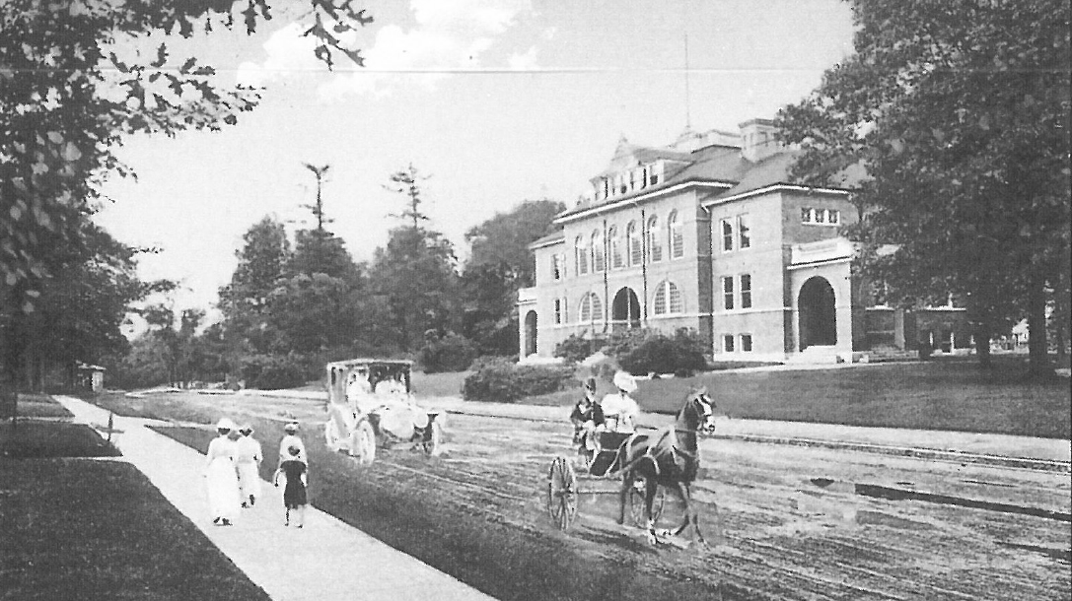
The building also is linked to two notable Needhamites. It was named after Judge Emery Grover, a prominent jurist and local official, who served as a Selectman and a School Committee member. In addition, the building was built on land donated by William Mosely, an important manufacturer of silk and elastic stockings, knit surgical bandages, and underwear. Mr. Mosely served as Town Moderator for twenty-eight town meetings from 1899 to 1922, as well as Town Auditor, a Selectman and a School Committee member.
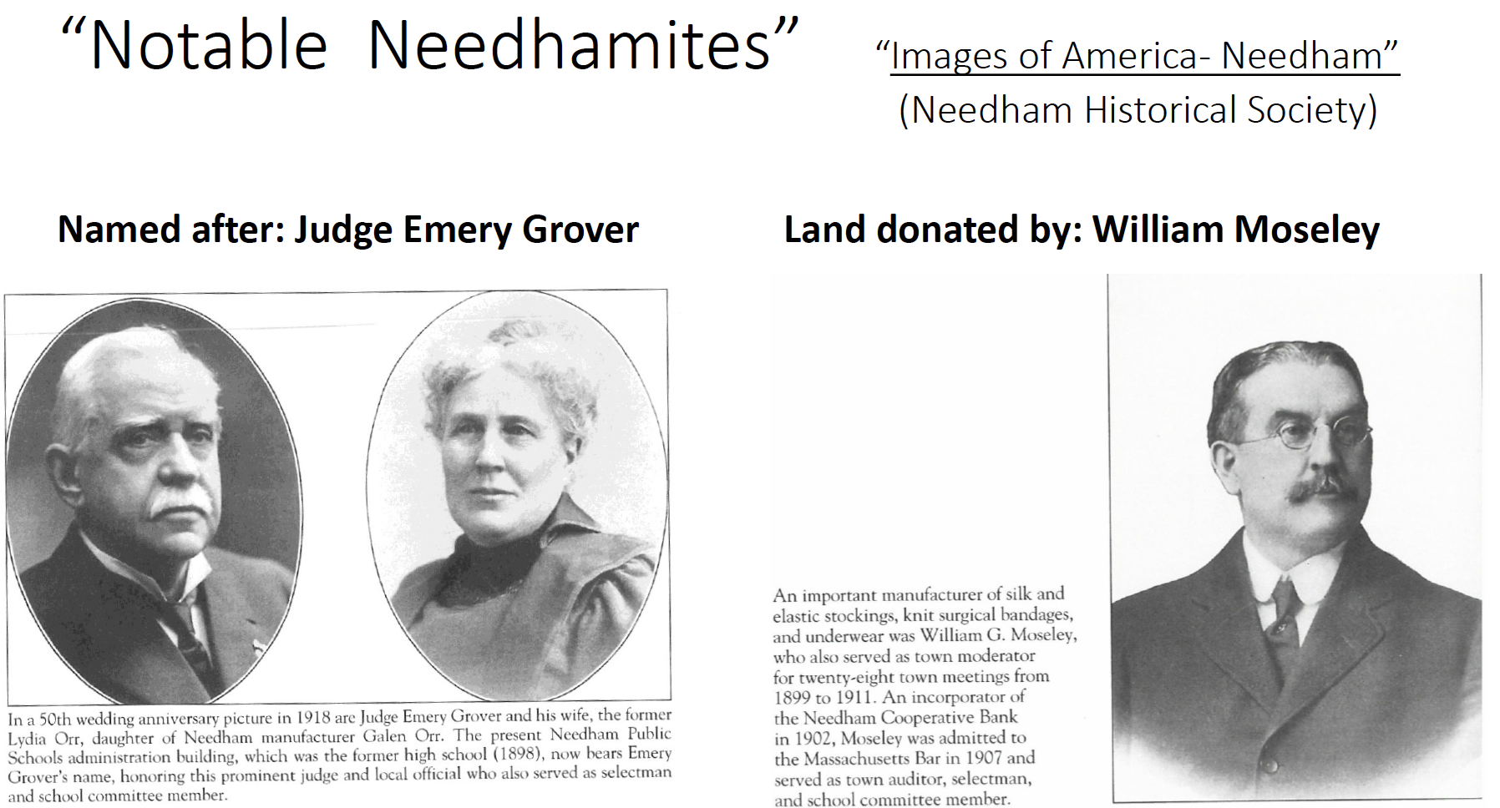
“Images of America – Needham,” courtesy of the Needham Historical Society
Like Town Hall, the Emery Grover building is a significant National Historic Register landmark, which serves as a gateway building and anchor to the historic downtown area. Placed on the National Register of Historic Places in 1987, it is an iconic feature of Needham, contributes to the attractive appearance of the downtown area and conveys a sense of community pride.

- Is the Historical Commission opposed to demolition of the Emery Grover Building?

Yes, the Historical Commission is unanimously opposed to the demolition of the Emery Grover building. At its September 27, 2021 meeting, the Commission voted unanimously to support the updated renovation plan for the Emery Grover Building. As noted by Ross Doherty, Chair of the Needham Historical Commission, the revised plan is ”both cost-effective and historically appropriate... The Emery Grover Building is Needham’s oldest public building and an iconic structure at the gateway to the downtown. It was built at the threshold of a new century, representing not only Needham’s long-standing commitment to educating its children, but also our progress, optimism, and aspirations. It is a part of the community landscape that helps to create civic engagement.”

- Would the proposed renovation project advance the Town’s state-mandated goal of achieving net zero carbon emissions by 2050?

Yes, the renovated building would advance the Town’s goal of achieving net zero carbon emissions from several standpoints.
A benchmark study conducted by the National Trust for Historic Preservation concluded that when comparing buildings of equivalent size and function, building reuse almost always offers environmental savings over demolition and new construction. This is because renovation and reuse of an existing building takes advantage of the embodied carbon from the existing foundations, brickwork, and structure already in place. This compares to a new building (following demolition), which would start off with a significant carbon deficit, due to the loss of the building’s embodied carbon and the carbon fuel expended during demolition and trucking the materials to a landfill. Even if a new building were very energy efficient, it could still take a decade or more for a new building to overcome the negative climate impact of new construction.

Additionally, the renovated building would be nearly as energy efficient as a new building, once all mechanical, electrical and plumbing (MEP) and building envelope systems were replaced or updated. As such, the Town is likely to experience a similar reduction in energy bills from either renovation or new construction.

Finally, the Town will be able to pursue net zero targets for the building through the design process. The pathway to Net Zero or “Net Zero Ready” will require careful attention to reducing the energy demand within the building by enhancing the insulation of the envelope ( windows & roof), installing energy efficient MEP systems (such as LED lighting, and air or ground source heat pumps) and utilizing renewable energy on or off site. Solar panels cannot be installed on the roof of a renovated Emery Grover building, but the design team will consider energy generating alternatives like a canopy of solar panels in the parking lot. Should the Town recommend that the building be designed to meet the enhanced performance standards of the State’s new, Net Zero Stretch Codes, which are projected to be open for Community adoption in 2022 and Mandatory statewide by January 1, 2028, that decision could be incorporated into the design and construction of the building.

- Is historic renovation in conflict with energy efficient design?

No, good preservation standards recognize that a working building must be maintained and updated to current standards. The Historical Commission will work with the PPBC to ensure that the preservation and efficiency are compatible, as happened with Town Hall. A Mass Save analysis is part of the designer’s scope for the Major Renovation which will analyze the costs and benefits for a variety of Deep Energy Savings.

- What are the next steps?

If Article #21 is approved, the PPBC would be able to award the Hillside construction project for renovations to prepare the swing space and BH+A would continue the Construction Document, and Bidding design phases for the Emery Grover building through September 2022. Bids would be in hand prior to October 2022 STM enabling the PPBC to determine the amount of additional construction contingency needed for the project prior to awarding the EG construction contract.

Article #21 funding would be used to move the School Administration into the temporary facilities at Hillside in December 2022 so that the renovation of Emery Grover could proceed in January 2023. The fully renovated Emery Grover building would open in June 2024, and the School Department would move back in after the school year ends in mid to late June 2024.

- What happens if Article 21 is not approved?

If Article 21 is not approved, the Superintendent will recommend to the School Committee that the Emery Grover building be abandoned within the year, and that school administration seek appropriate leased space. The Superintendent also will include in the FY23 School Department operating budget a $900,000 request for rental expense, plus up to $2.63 million in the capital plan to fit out the leased space. These funds would be in addition to other school operating requests.

- How does Article 22– Appropriate for Hillside School Heating Repairs and Upgrades relate to Article 21?

During the study of the Hillside building for school administration swing space it was determined that the most cost-effective system for heating and cooling the building was a hybrid system. This includes the repair of the existing heating system with replacement of the failed boiler with a new more energy efficient boiler. The boiler repairs will be done concurrently with the renovation project. These are necessary to maintain the operations of the building after School Administration moves out in the summer of 2024. By maintaining the existing heating system the renovation project will be able to limit the number of new air- sourced heat pumps (ASHP) that are installed for only the office areas in the building. These ASHPs will replace the old inefficient thru wall air conditioners. The School IT operations division moved into the Hillside building “temporarily” during COVID and will likely remain in the Hillside building.

- Where can I get more information?

- All documents, including presentations, reports, and information about the EG Project can be located in one place on the district’s website: Emery Grover Project Information
- To read a brief summary of the issues and challenges at the Emery Grover School Administration and Operations Building, read the Superintendent’s August 2021 Blog
- Town Meeting Members may wish to email questions or comments to the School Committee: schoolcommittee@needham.k12.ma.us or the Superintendent of Schools, dan_gutekanst@needham.k12.ma.us.

